**Sequence Diagram:**

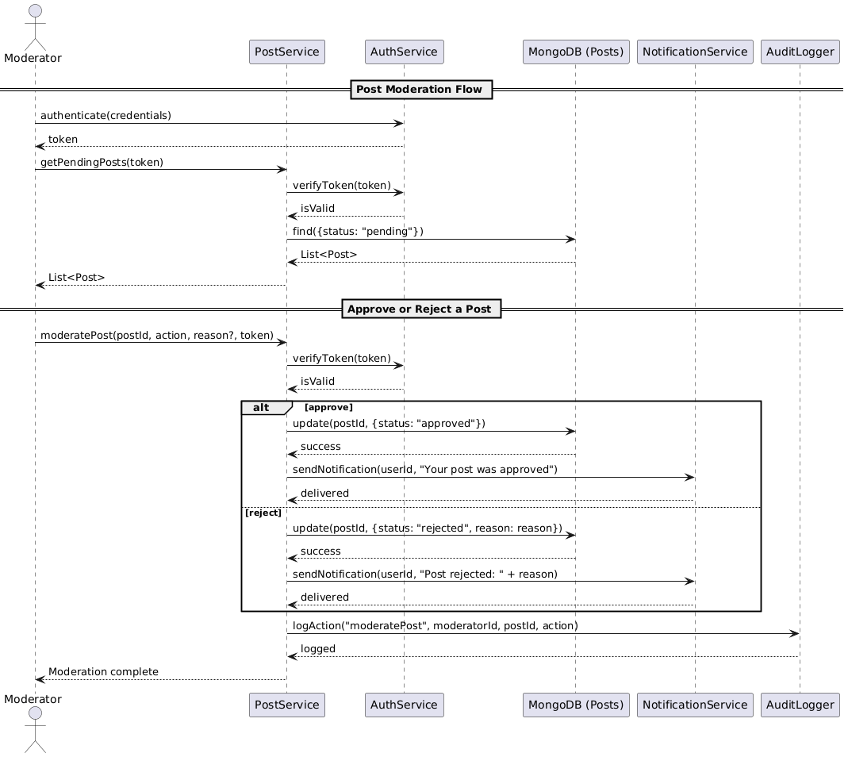

**Class Diagram:**

**State Diagram:**

**ERD:**

**Functional Requirements**

1. The system must allow moderators to view newly submitted posts.
2. The system must enable moderators to approve or reject posts.
3. Rejected posts must be stored with a rejection reason.
4. Users must receive notifications about approval or rejection.
5. Approved posts must be published to the platform immediately.
6. Admins can view moderation history with timestamps and moderator IDs.
7. Moderators should be able to filter posts by status (pending/approved/rejected).
8. Only authenticated moderators can access moderation features.

**Non-Functional Requirements**

1. The moderation decision should be recorded within 1 second of action.
2. The system must be available 99.9% of the time.
3. Notification delivery must occur within 2 seconds.
4. Only authorized moderators should be able to perform actions (role-based access).
5. All moderation actions must be logged for audit purposes.